## Front End Engineering-II

Project Report

Semester-IV (Batch-2022)

**Furniture Store**

**(REACT)**



**Supervised By: Submitted By:**

Raveesh Samkaria Sai Madhav Bhalla-2210990760

G-12

**Department of Computer Science and Engineering**

## Chitkara University Institute of Engineering & Technology,

## Chitkara University, Punjab

**Abstract**

The Furniture Store project endeavours to create an engaging and interactive web-based application using React, Vite, and CSS. Its primary aim is to provide users with a seamless platform for exploring and experiencing the culinary delights of Furniture Store, a premium furniture store. This report outlines the project's objectives, methodology, and significance in enhancing customer engagement and technological integration.

With the increasing demand for intuitive and aesthetically pleasing store websites in the digital era, an effective online presence is essential for attracting and retaining customers. However, existing solutions often lack seamless integration and engaging features. This project addresses these shortcomings by leveraging modern web technologies to deliver a dynamic and user-friendly browsing experience.

The objectives include developing a responsive web-based application accessible across devices and browsers, offering a comprehensive menu with detailed descriptions and images, integrating interactive features such as online reservations and customer reviews, and ensuring a visually appealing design that reflects the store brand identity.

The significance of the Furniture Store project extends beyond its technical implementation. By providing an engaging platform accessible to users worldwide, it enhances customer experience, digital literacy, and brand loyalty. Additionally, it showcases the capabilities of modern web technologies in delivering immersive and interactive experiences, highlighting the boundless possibilities of digital innovation in the Store industry.

**Table of Contents**

|  |  |  |  |
| --- | --- | --- | --- |
| **S No.** | **Contents** | **Page No** | **Remarks** |
| 1. | Introduction   * Background * Objectives * Significance | 4-7 |  |
| 2. | Problem Definition andRequirements   * Problem Statement * Software Requirements * Hardware Requirements | 8-10 |  |
| 3. | Proposed Design / Methodology   * Design Concept * Methodology * File Structure | 11-13 |  |
| 4. | Code   * HTML * CSS * JavaScript | 14-38 |  |
| 4. | Results   * Screenshots | 39-40 |  |
| 5. | References | 41 |  |

1. **Introduction**
   * **Background**

The inception of the Furniture Store website project originates from the need to create a captivating, user-friendly digital platform that showcases the unique offerings of the Furniture Store Store. Traditional Store websites often suffer from poor design, limited functionality, and lack of interactivity, which can deter potential customers.

The Furniture Store project aims to overcome these challenges by leveraging cutting-edge web technologies such as React, Vite, and CSS to develop an engaging and intuitive website. This platform is designed to be easily navigable, visually appealing, and fully responsive, ensuring an optimal user experience across various devices and browsers. By harnessing the power of React's component-based architecture and Vite's fast build times, the project ensures a smooth and efficient development process, resulting in a high-performance website.

Furthermore, the Furniture Store website aspires to offer a comprehensive range of features, including an interactive menu with detailed item descriptions and high-quality images, online reservation capabilities, and customer reviews. These functionalities are intended to provide users with a holistic view of the Storeofferings and enhance their overall experience. The use of advanced CSS techniques ensures that the website's design is not only attractive but also reflective of the Storebrand identity and culinary artistry.

* + **Objectives**

The Furniture Store website project is driven by a set of clear and strategic objectives aimed at enhancing the Store digital presence and improving user experience. These objectives include:

**Develop a Responsive Web-Based Application:** Create a website that is fully accessible and performs seamlessly across all devices and browsers. This ensures that users can explore Furniture Store effortlessly, whether they are on a desktop, tablet, or mobile device.

**Showcase the Menu with Detailed Descriptions and High-Quality Images:** Provide an interactive and comprehensive menu that highlights the Store offerings. Each menu item will feature detailed descriptions and high-resolution images to give users a vivid preview of their Store options.

**Ensure a Visually Appealing and Brand-Consistent Design:** Use advanced CSS techniques to create a website that is not only aesthetically pleasing but also consistent with the Furniture Store brand identity. The design will reflect the Store ambiance.

**Leverage Modern Web Technologies for Enhanced Performance:** Utilize React for a dynamic and efficient user interface, Vite for fast development and build processes, and CSS for stylish and responsive design. This combination of technologies will ensure a high-performance website.

* + **Significance**

The significance of the Furniture Store website project extends beyond its technical implementation, encapsulating several key dimensions:

**Enhanced Customer Experience:** By providing an engaging and user-friendly online platform, the Furniture Store website enhances the overall customer experience. It allows users to easily explore the store, make reservations, and leave feedback, creating a seamless and enjoyable interaction with the Store.

**Brand Identity and Visibility:** The website serves as a digital representation of Furniture Store, reflecting its brand identity. A visually appealing and well-designed website helps to strengthen the Store brand presence and attract potential customers, thereby increasing visibility and recognition in the competitive Store market.

**Accessibility and Convenience:** The web-based platform ensures that Furniture Store is accessible to a wide audience, including those using various devices and web browsers. This inclusivity lowers barriers to entry, allowing more people to discover and engage with the Store offerings from anywhere at any time.

**Customer Engagement and Loyalty:** By incorporating features such as online reservations, customer reviews, and interactive elements, the website fosters deeper engagement with customers. This not only enhances user satisfaction but also builds customer loyalty and encourages repeat visits.

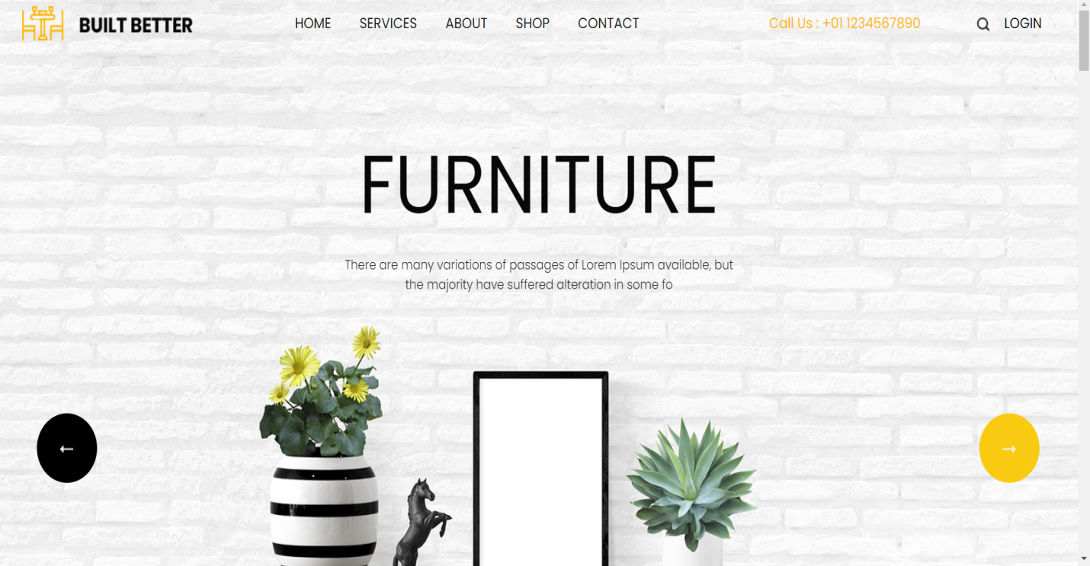

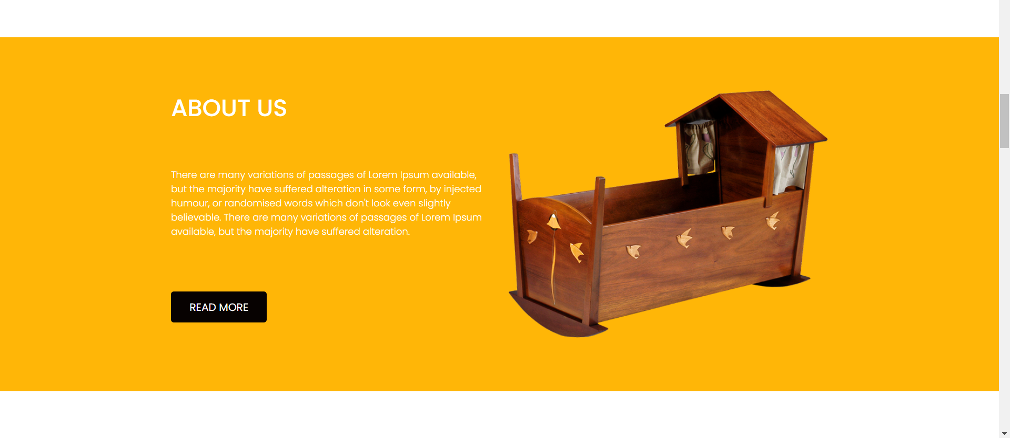

1. **Problem Definition and Requirements**
   * **Problem Statement**

**Limited Digital Presence:** The Store lacks a comprehensive and visually appealing online platform to showcase its ambiance, and unique offerings. This limits its ability to reach potential customers and compete effectively in the digital landscape.

**Inefficient Reservation Process:**The current reservation system, if any, may be outdated or cumbersome, leading to inefficiencies and customer dissatisfaction. This can result in missed reservation opportunities and lost revenue for the Store.

**Lack of Customer Engagement:** Without interactive features such as customer reviews, feedback forms, or social media integration, the Store struggles to actively engage with its patrons and build a loyal customer base. This hampers its ability to foster community and brand advocacy.

**Inconsistent Brand Representation:** The absence of a cohesive online presence may lead to inconsistencies in brand representation across various digital channels. This can dilute the Store identity and weaken its brand perception among potential customers.

**Limited Reach and Accessibility:** Platform dependency and lack of responsive design may hinder access to the Store online resources for users on different devices or with varying accessibility needs. This restricts the Store ability to connect with a diverse audience and maximize its reach.

* + **Software Requirements**

**Web Browser:** The Furniture Store website is designed to be accessed via web browsers. It is compatible with modern browsers such as Google Chrome, Mozilla Firefox, Safari, and Microsoft Edge. Users should have a stable internet connection to access the website seamlessly.

**Code Editor:** Developers working on the Furniture Store website project require a code editor for editing HTML, CSS, and JavaScript files. Recommended code editors include Visual Studio Code, Sublime Text, Atom, and Brackets. These editors provide features such as syntax highlighting, code completion, and debugging tools to facilitate efficient development.

**React and Vite:** The Furniture Store website is built using React for creating dynamic user interfaces and Vite for fast development and hot module replacement. Developers should have Node.js installed on their systems to install and manage project dependencies using npm or Yarn.

**Operating System:** The Furniture Store website project can be developed and run on various operating systems, including Windows, macOS, and Linux. Developers should ensure that their operating system is up-to-date and compatible with the required development tools and dependencies.

**Internet Connection:** An internet connection is required for accessing documentation, downloading dependencies, and testing the Furniture Store website in a web browser environment. Developers should have a stable internet connection to facilitate efficient development and collaboration.

* + **Hardware Requirements**

The hardware requirements for running the project are relatively minimal and include the following:

* + - **Processor:** A multi-core processor, such as an Intel Core i5 or AMD Ryzen equivalent, is recommended for optimal performance during development and testing.
    - **Memory (RAM):** A minimum of 4 GB of RAM is recommended for running development tools, code editors, web browsers, and other software concurrently.
    - **Storage:** Sufficient storage space is needed to store project files, code, assets, and dependencies. A solid-state drive (SSD) is preferred for faster read/write speeds and improved performance.
    - **Input Devices:** A keyboard and mouse (or trackpad) are essential for interacting with the computer and navigating the development environment.
    - **Internet Connection:** An internet connection is required for accessing documentation, downloading dependencies, and running the website in a web browser environment.

1. **Proposed Design/Methodology**
   * **Design Concept**

**Requirement Analysis:** The methodology begins with a comprehensive analysis of user requirements, preferences, and expectations for the Furniture Store Store website. This involves gathering feedback from potential customers, studying competitor websites, and identifying key features essential for the success of the website. User surveys, interviews, and market research are conducted to gain insights into user needs and industry trends in the culinary landscape.

**Frontend Development:** The frontend development phase focuses on implementing the user interface design using React. Responsive layouts are created to ensure compatibility across various devices and screen sizes. Styling interface elements is done using frameworks like Bootstrap or custom CSS, adhering to the design principles established during the prototyping phase. Interactive features such as menus, reservation forms, and gallery sliders are implemented using JavaScript libraries to enhance user engagement.

**Testing and Quality Assurance:** Throughout the development process, rigorous testing and quality assurance measures are employed to identify and address any issues or bugs. Functional testing is conducted to ensure that all features work as intended, including forms submission, menu navigation, and image galleries. Compatibility testing is performed to verify cross-browser and cross-device compatibility, ensuring a consistent user experience across different platforms. Performance testing is carried out to optimize page load times and responsiveness, enhancing overall website performance.

* + **Methodology**

**Requirement Analysis:** The methodology initiates with an in-depth analysis of user needs, preferences, and expectations for the Furniture Store Store website. Through surveys, interviews, and market research, we gather insights into customer behaviours, competitor benchmarks, and industry trends. This phase aims to identify essential features and functionalities crucial for creating an effective online presence for the Store.

**Frontend Development:** With approved prototypes in hand, the frontend development phase begins. Using React we translate the design concepts into interactive web pages. Special attention is given to responsive design principles to ensure compatibility across various devices and screen sizes. The user interface elements are styled to reflect the Storebranding and ambiance, creating a cohesive visual identity.

By adhering to this methodology, the Furniture Store website project aims to deliver an engaging, user-friendly online platform that effectively showcases the Storeofferings, enhances customer engagement, and reinforces its brand presence in the competitive culinary landscape.

* + **File Structure**

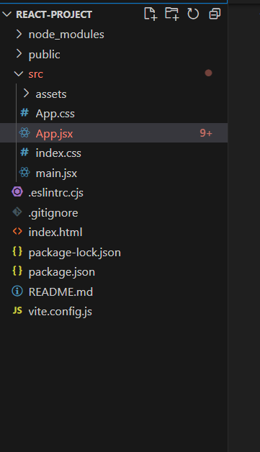

**HTML**

* Components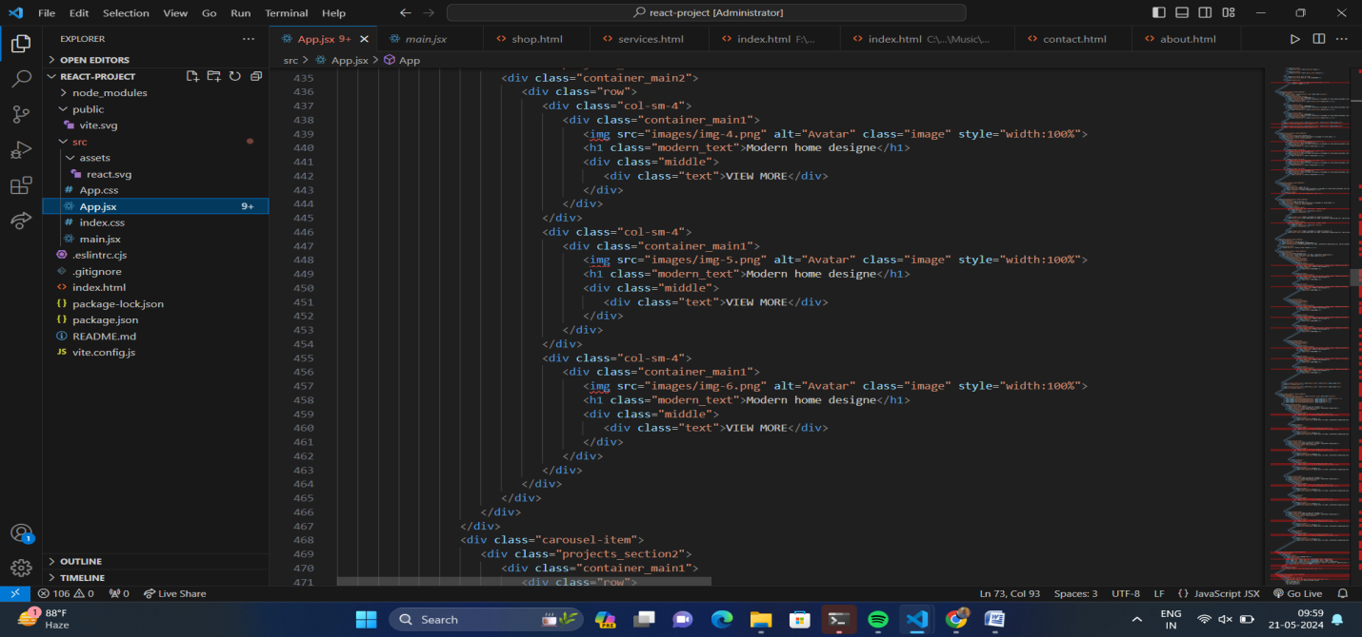

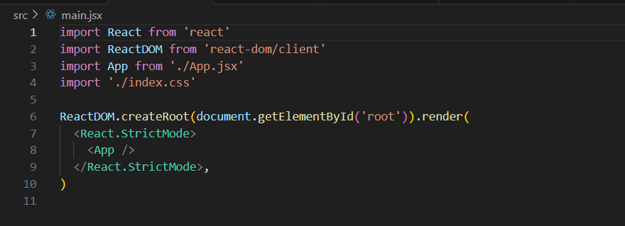

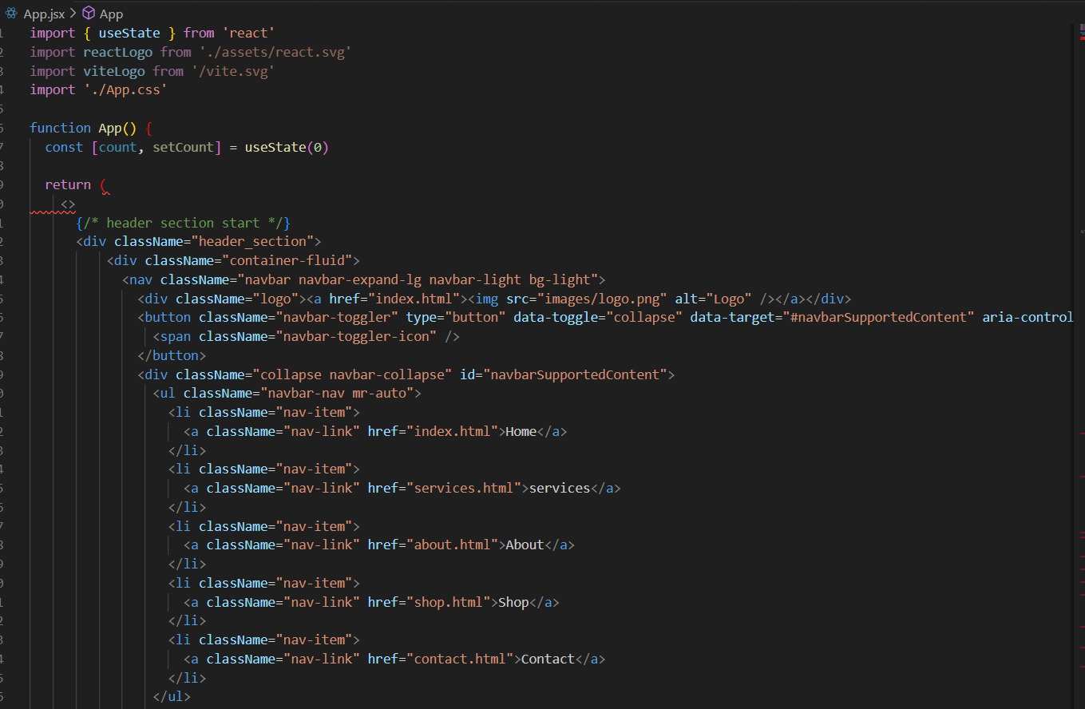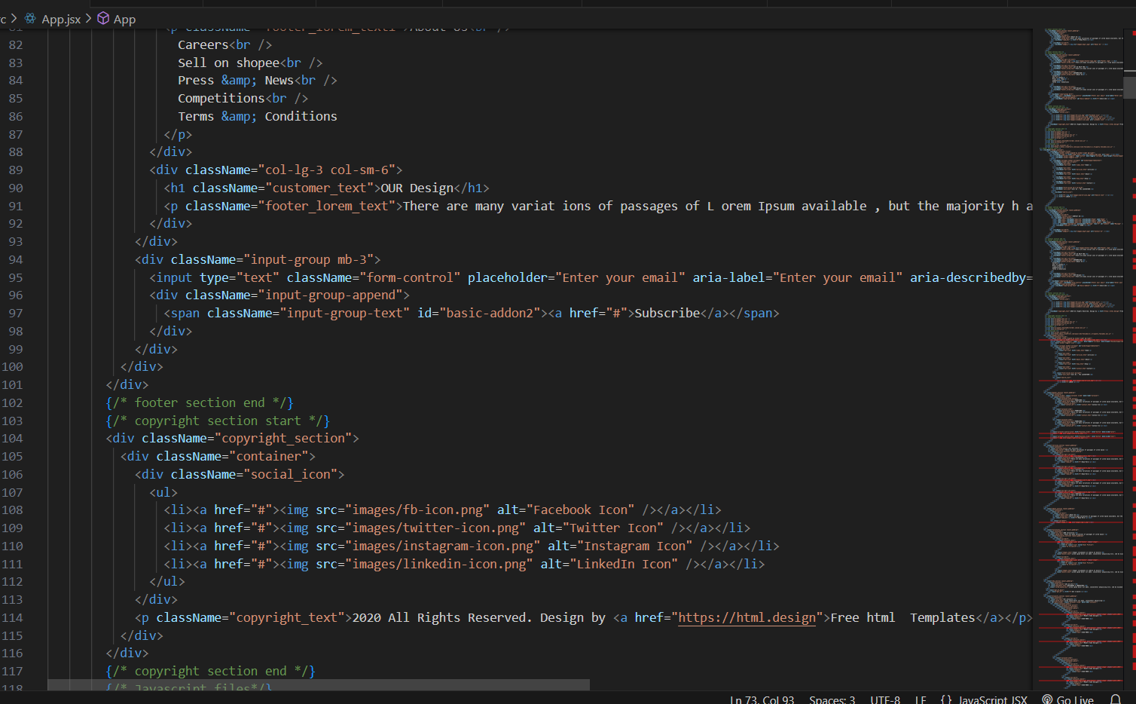

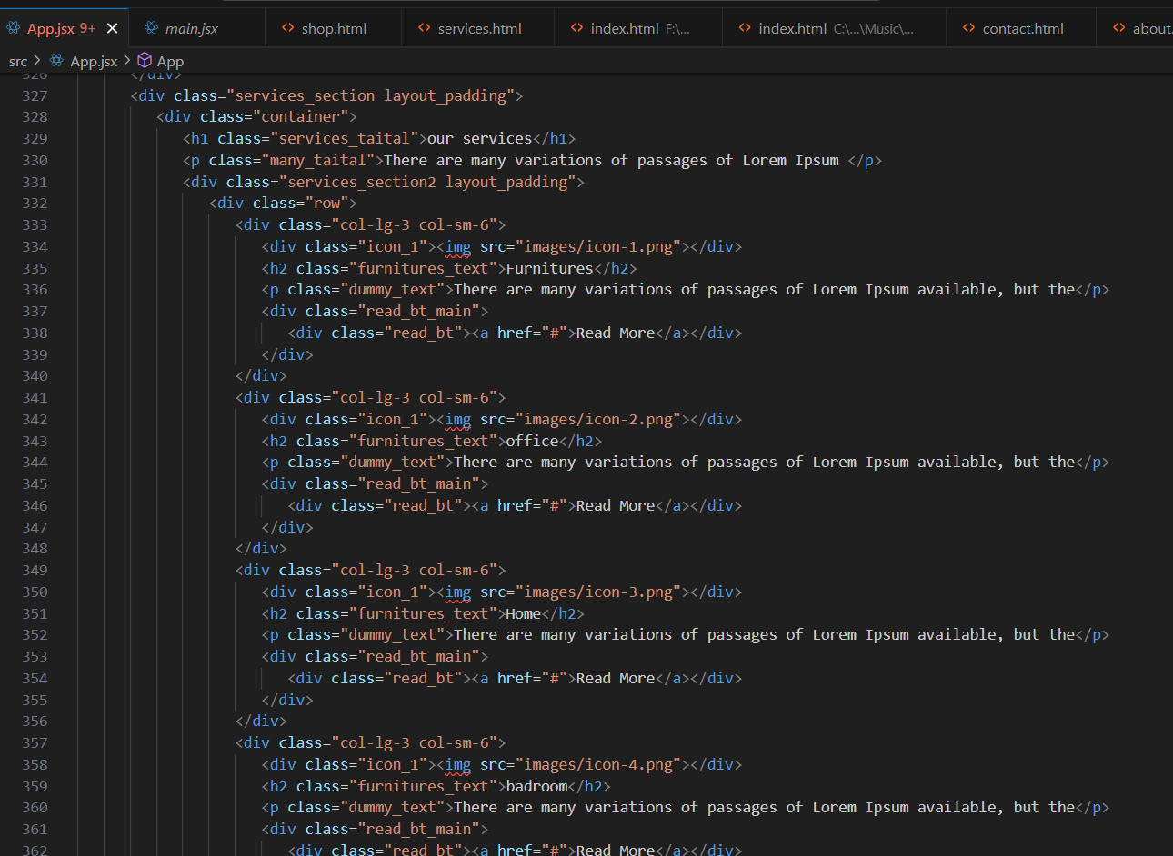

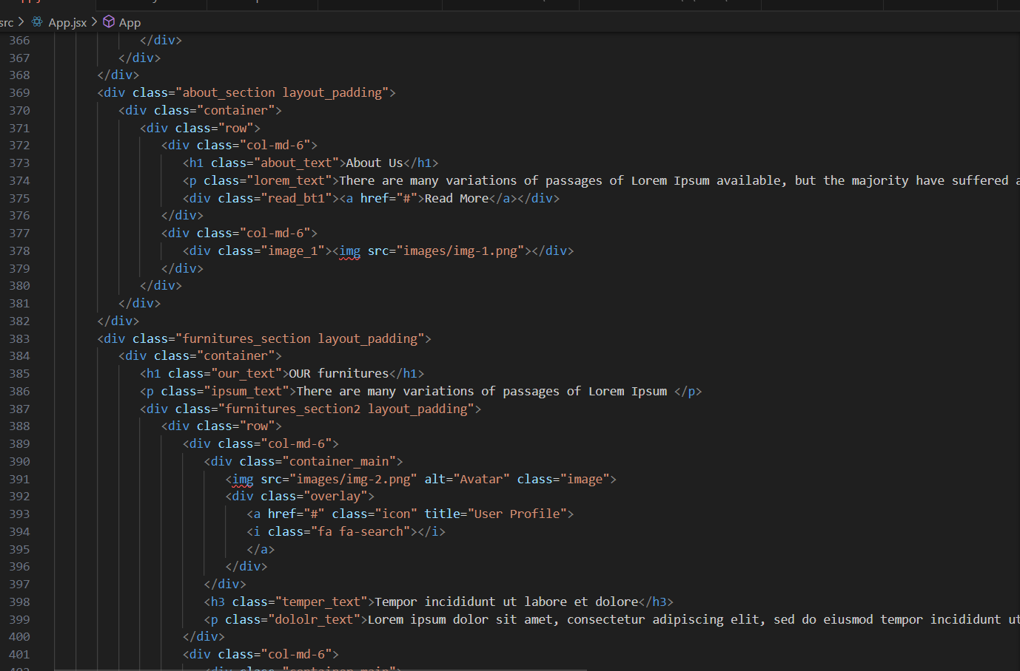

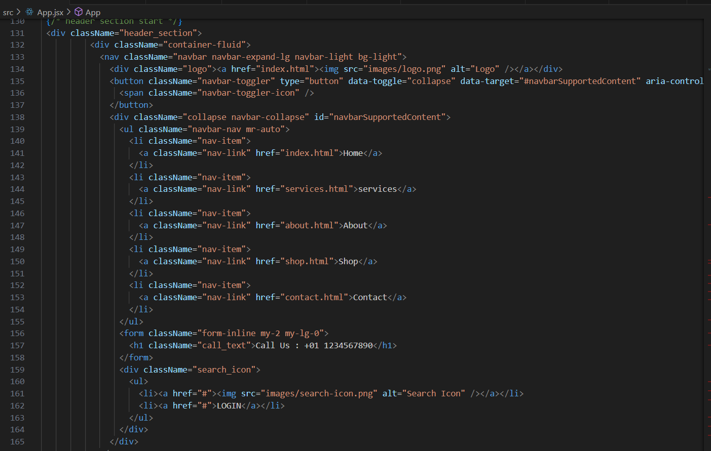

gvhgvhvv

Reference:-

• React Documentation: http://react.dev/

• W3Schools: https://www.w3schools.com/REACT/DEFAULT.ASP

• React Slick: https://www.npmjs.com/package/react-slick

• React Scroll : https://www.npmjs.com/package/react-scroll